Chapter 6 Secondary Activities

## What is secondary activity ?

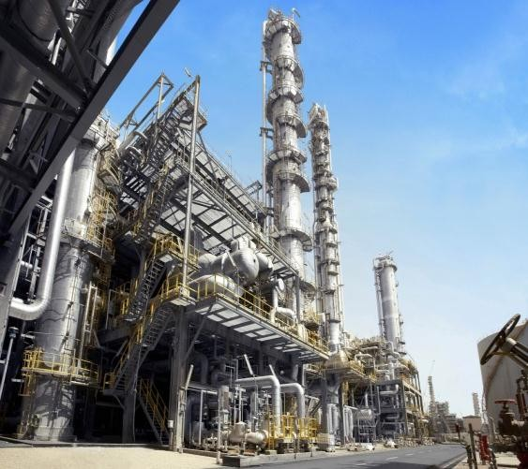

Secondary activities add value to natural resources by transforming raw materials into valuable products. Therefore, secondary activities are concerned with manufacturing

,processing and construction ( infrastructure )industries.

# Manufacturing

The literally meaning of manufacturing is to make by hand, but in the present context, the manufacturing means the conversion of raw material into more useful and valuable fabricated articles with the help of machines.

# Manufacturing Industries

* These are geographically located manufacturing units that transform raw materials into finished goods of higher value for sale in local or distant markets.
* The term industry is comprehensive and can also be used in many secondary activities whichare not carried on in factories like entertainment industry, tourism industry, etc.

CH-6 SECONDARY ACTIVITIES Page 1

**Characteristics of modern large scalemanufacturing/ Industries**

**Specialisation** of Skills In industries, one task is done repeatedly that gives specialisation of doing that task.

This involves high cost of manufacturing. On the other hand, mass production involves production of large quantity of standardised parts by each worker performing only one task repeatedly.

**Mechanisation** The industries use automated processes or machines which does the major production. Human thinking is not required in mechanisation.

**Technological Innovation** Latest technology is used and constant innovation is done to eliminate waste,quality control, combat pollution and bring efficiency.

**Organisational Structure and Stratification** Modern manufacturing is characterised by complex machine technology, extreme specialisation, division of labour, vast capital, large organisations and executive bureaucracy.

**Uneven Geographic Distribution** The industries are concentrated in regions that are rich in mineral andother resources. These areas cover less than 10% ofthe world’s land area. These regions have become the major centres of economic and political power

# Location of industry

* The location of industry at a particular place is governed by a large number of geographical and non•geographical factors. Industries maximise profits by reducing costs.
* Thus, industries should belocated at points where the production costs are minimum.
* Following factors influence the location of industry at particular places:

## Access to Market

Areas that provide large markets for finished industrial goods like developed areas ofEurope, America, Japan, Australia, South Asia have huge concentration of industries.

## Access to Sources of Energy

Coal, petroleum andhydroelectricity are main sources of energy. Industries using more power are located close tothese sources.

## Access to Raw Material

Industries based on cheap,bulky and weight•losing materials (ores) like steel, sugar are based close to sources of raw materials. Similarly, processing of dairy products, perishable foods and agro based are done near the sources ofraw materials.

## Access to Labour Supply

Industries are located where there is availability of skilled labour. Some types of manufacturing still require skilled labour.

## Acccess to Source of Energy

* Industries which usemore power are located nearer to the source of energy supply such as iron and steel industries.
* Energy is most essential to run machines in industries. The main power resources are coal, petroleum, hydroelectricity, natural gas and nuclearenergy.

## Access to Transportation and Communication

Facilities Industries are located in places that haveefficient transportation facilities and communication services for the exchange and management of information.

## Access to Agglomeration Economies

Agglomeration economies refer to the benefits derived from the linkages that exist between different industries. Thesmall industries or ancillary units like to operate near leader industries to benefit from nearness tobig or basic industries.

## Government Policy

For the balanced economic development, governments promote various regions by setting up industries in a particular link between industrial areas.

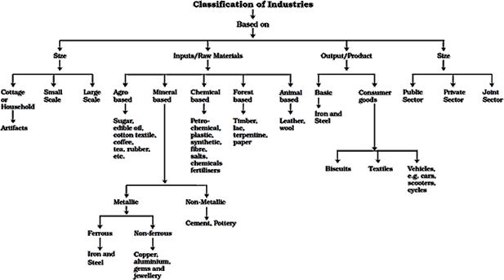

# Classification of Manufacturing Industries

Industries are classified on the basis of their size, inputs/ raw materials, output/ products and ownership

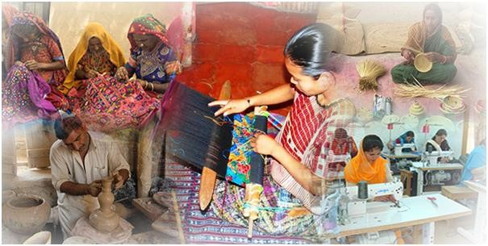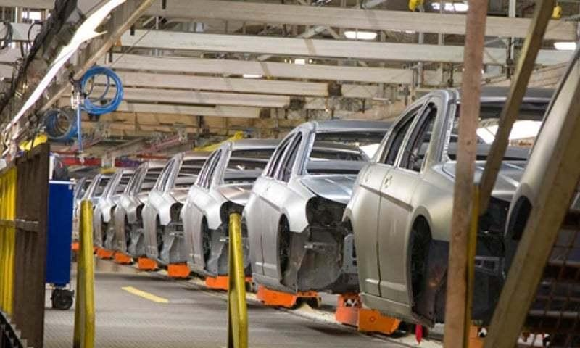

# Industries Based on Size

Based on amount of capital invested, a number ofworkers employed and volume of production, industries are classified into the following:

## Household Industries or Cottage Manufacturing

* It isthe smallest manufacturing unit. Artisans use local raw materials, simple tools and production is done with the help of family members. Production is done for local consumption and local markets.
* There is not much capital needed, e.g. mats, baskets, pottery, jewellery, artefacts and crafts.

## Small Scale Manufacturing

* These type of industriesemploy semi-skilled labour, operate by power driven machines, use local raw materials and manufacture products in workshops. It provides employment and raises local purchasing power.
* India, China, Indonesia and Brazil have developedlabour intensive small scale manufacturing units.

## Large Scale Manufacturing

* + Here mass productiontakes place, involves large market, many raw materials, huge energy requirements, specialised workers, advanced technology and large capital.
  + Large scale manufacturing industries are divided into two parts i.e. Traditional large scale industrialregions and Higlr technology large scale industrial regions.

# Industries Based on Inputs/Raw Materials

On the basis of raw materials used, industries areclassified as follow:

## Agro based Industry

* + This involves processing of rawmaterials from the fields and farms into finished products like sugar, fruit juices, beverages, oils andtextiles (cotton, jute, silk), rubber, etc.

## Food Processing

* + This is part of agro based industryand includes processes like canning, producing cream, fruit processing, confectionery, drying, fermenting and pickling.

## Agri Business

* + This is commercial farming on an industrial scale. The farms are mechanised, very large and highly structured, like tea plantation andtea factories near the plantations.

## Mineral based Industry

* + These are industries that use minerals as raw materials such as ferrous like iron and steel and non•ferrous like aluminium, copper, etc.
  + Mineral based non•metallic industriesare of cement and pottery.

## Chemical based Industry

* + These industries use natural chemical minerals like salts, sulphur, potash,mineral oil in petrochemical industry and chemicals obtained from wood and coal.
  + Synthetic fiber and plastics are other examples of chemical based industry.

## Forest based Industry

Industries that use forest products such as timber, wood, bamboo, grass, lac,etc come under forest based industry.

## Animal based Industry

Industries that use animal products such as leather, woollen textiles, ivory aregrouped under animal based industry.

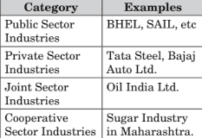

# Industries based on Output/ Product

This refers to industries based on the finishedproducts or output. These are:

## Basic Industries

* These are the industries that produce raw material to be used in other industriessuch as iron and steel.
* Consumer Goods Industries These are the industrieswhich produces what is consumed by consumers directly such as tea, biscuits, toiletries, etc.

## Industries based on Ownership

Based on the ownership, the industries are grouped as:

## Public Sector Industry

This refers to industries that are owned and managed by government. In India, itis called public sector undertakings. Socialist economies have all state owned industries.

## Private Sector Industry

This refers to industries thatare owned by private individuals and also managed by them. Capitalist economies have mostly private owned industries.

## Joint Sector Industry

Industries that are jointly owned and managed by joint stock companies or established by private and government sector are called joint sector industries.

## Foot Loose Industries

These industries do not depend on any specific rawmaterial so they can be located at any place. They largely depend on component parts, employ small labour force and produce in small quantity.

## Traditional Large Scale Industrial Regions

* Traditional large scale industries are mostly heavy industries located near coal fields and involved in metal smelting, heavy engineering, chemical manufacturing or textile production.
* Their featuresare high employment, high density of housing but
* poor services, unattractive environment, pollutionand waste heaps. Due to these problems, many industries are closed leading to unemployment, emigration and wastelands.

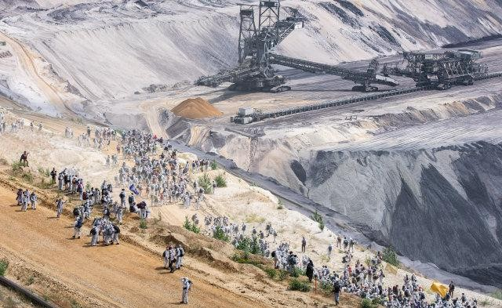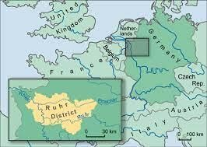

# The Ruhr Coal Field , Germany

This area was a major industrial region due to coal and iron-ore deposits. But the industry started shrinking as demand of coal declined, iron-ore exhausted, industrial waste and pollution increased.

Now a New Ruhr landscape has emerged that focusses on other products like Opel car assembly plant, new chemical plants, universities and out oftown shopping centres.

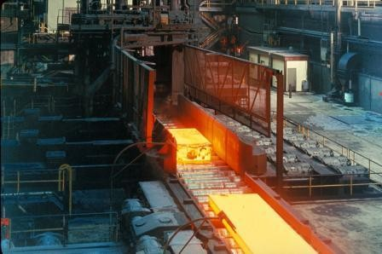

# High Technology Industry

* Also called high-tech industry, it is highly technicaland incorporates advanced scientific and engineering research and development strategy.
* The workforce are highly skilled specialists, professionals (known as white collar) who outnumber the production labour (blue collar).
* Robotics, computer aided design and manufacturing, electronics, new chemicals and pharmaceuticals are examples of these industries.

## Iron and Steel Industry

* It is known as basic industry as it provides raw materials or base to other industries. It is also calledheavy industry due to its bulky raw material and heavy finished products.
* These industries are located near the source of raw materials i.e. iron ore, coal, manganese and
* limestone or near ports where it could be early brought.

## Distribution

This industry is spread in developed and developingcountries such as America, UK, Germany, France, Belgium, Ukraine, Japan, China and India (Jamshedpur, Durgapur, Raurkela, etc.)

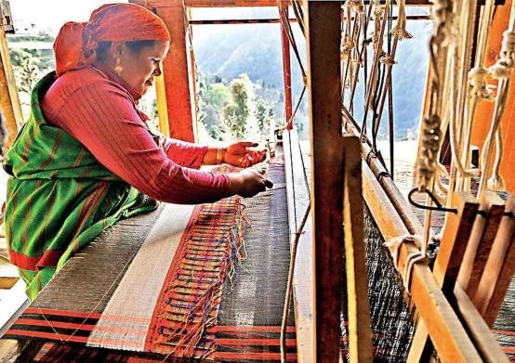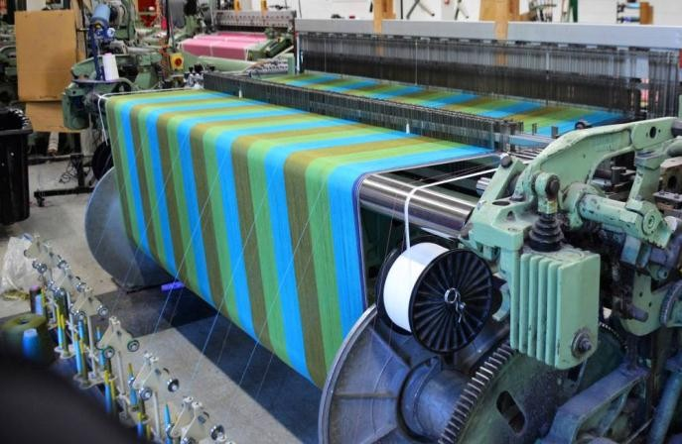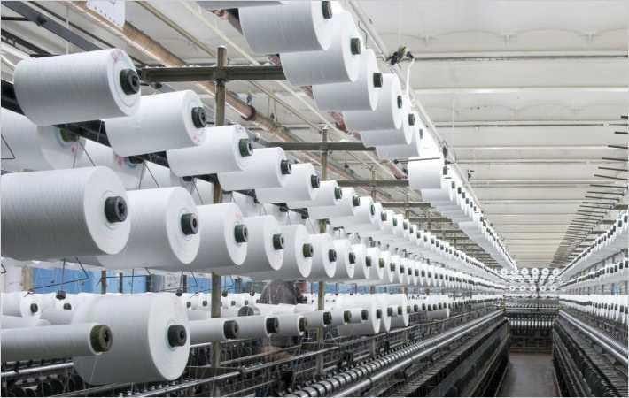

**Handloom**

This is labour intensive, employs semi- skilled workers, requires small capital and involves processes like spinning, weaving and finishing of thefabrics.

**Powerloom**

This is less labour intensive, uses of

machines and production is more

**Mill Sector**

This is highly capital intensive, requiresgood quality raw cotton and produces in bulk.

# Cotton Textile Industry

This industry has three sub-sectors:

* India, China, USA, Pakistan, Uzbekistan and Egypt produce more than half of world’s raw cotton. Nowthe cotton textile industry is shifting to less developed countries due to labour

